Lab 6.6 Jobs

- Create a job.yml file as shown below:
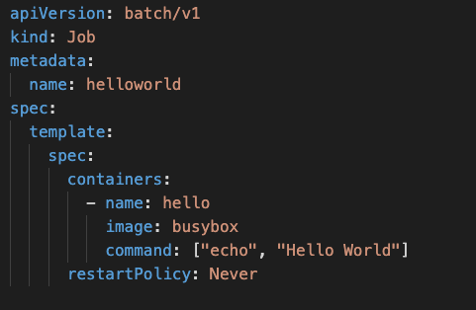

- Create a Job
kubectl create -f job.yml

- Check the completion status of the job
kubectl get jobs

- Have a look at the logs of the Pod
kubectl logs -f <podName>

- Have a look at more details of the Job
kubectl describe job

- Delete the Job
kubectl delete job helloworld

- Add the completions and set it to value 2
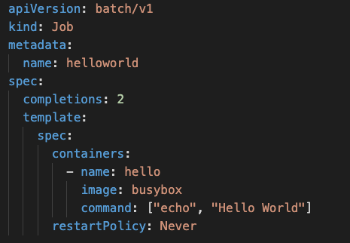

- Create the Job and test how many times it executes
kubectl create -f job.yml
kubectl get jobs

- Delete the Job
kubectl delete job helloworld

- Add Parallelism to the job
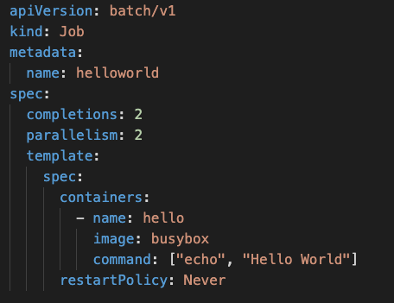

- Check that 2 pods get executed at one go in parallel
kubectl get all

- Delete the Job
kubectl delete job helloworld

- Change the command so that it fails and notice how many time it restarts
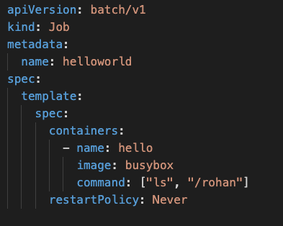

- Create the Job again and check status. Because of the error it will go on creating a new pod infinitely till the job is getting failed
kubectl create -f job.yml
kubectl get all

- Delete the job again
kubectl delete job helloworld

- Set the BackoffLimit to limit the number of times it restarts because of failure
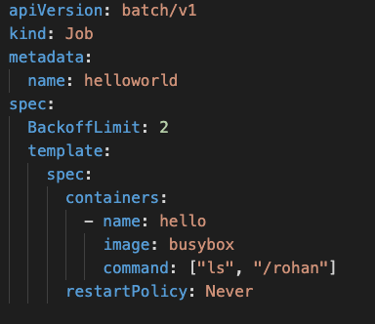

- Create the Job and check the Number of restarts is set to a number
kubectl create -f job.yml
kubectl get all

- Delete the job
kubectl delete job helloworld

- Add a time limit to how long a job should execute and if it crosses this limit, fail the job
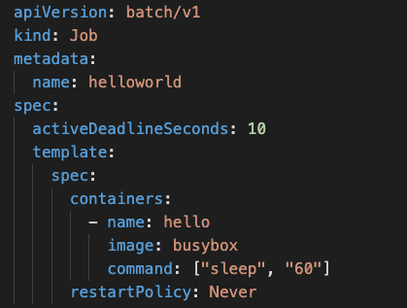

- Create the Job and check the status
kubectl create -f job.yml
kubectl get all

